DILSHAD
231501041

EXPERIMENT 4

AIM:
To create a web-based Java Servlet application that accepts a user's name and age through an HTML form and displays the submitted data back on the browser using Java Servlet technology.

CODE:
<!DOCTYPE html>

<html>

<head>

<title>User Form</title>

<style>

body {

font-family: Arial, sans-serif; background-color: #f4f4f4; display: flex;
justify-content: center;

align-items: center; height: 100vh; margin: 0;
}

.container { background: #fff; padding: 20px; border-radius: 10px;
box-shadow: 0px 0px 10px rgba(0, 0, 0, 0.1); text-align: center;
width: 300px;
}

h2 {

color: #333;

}

input[type="text"], input[type="number"] { width: 90%;
padding: 10px; margin: 10px 0; border: 1px solid #ccc; border-radius: 5px;
}
input[type="submit"] { background: #007BFF; color: white;

padding: 10px 15px; border: none;
border-radius: 5px; cursor: pointer; font-size: 16px; width: 100%;
}

input[type="submit"]:hover { background: #0056b3;
}

</style>

</head>

<body>

<div class="container">

<h2>Enter Your Details</h2>

<form action="UserServlet" method="post">

<input type="text" name="username" placeholder="Enter your name" required><br>

<input type="number" name="age" placeholder="Enter your age" required><br>

<input type="submit" value="Submit">

</form>

</div>

</body>

</html>

Java Servlet :

import java.io.IOException; import java.io.PrintWriter;
import javax.servlet.ServletException; import javax.servlet.annotation.WebServlet; import javax.servlet.http.HttpServlet;
import javax.servlet.http.HttpServletRequest; import javax.servlet.http.HttpServletResponse;

@WebServlet("/Exp4") // Make sure your form action matches this URL public class Exp4 extends HttpServlet {
protected void doPost(HttpServletRequest request, HttpServletResponse response) throws ServletException, IOException {
response.setContentType("text/html"); PrintWriter out = response.getWriter();
// Retrieving form data

String name = request.getParameter("username"); String age = request.getParameter("age");
// Output HTML response out.println("<html><body>");
out.println("<h2>Welcome, " + name + "!</h2>"); out.println("<p>Your age is: " + age + "</p>"); out.println("</body></html>");
}
}

Configure web.xml:
<web-app xmlns="http://java.sun.com/xml/ns/javaee" version="3.0">

<servlet>

<servlet-name>UserServlet</servlet-name>

<servlet-class>UserServlet</servlet-class>

</servlet>

<servlet-mapping>

<servlet-name>UserServlet</servlet-name>

<url-pattern>/UserServlet</url-pattern>

</servlet-mapping>

</web-app>

OUTPUT:
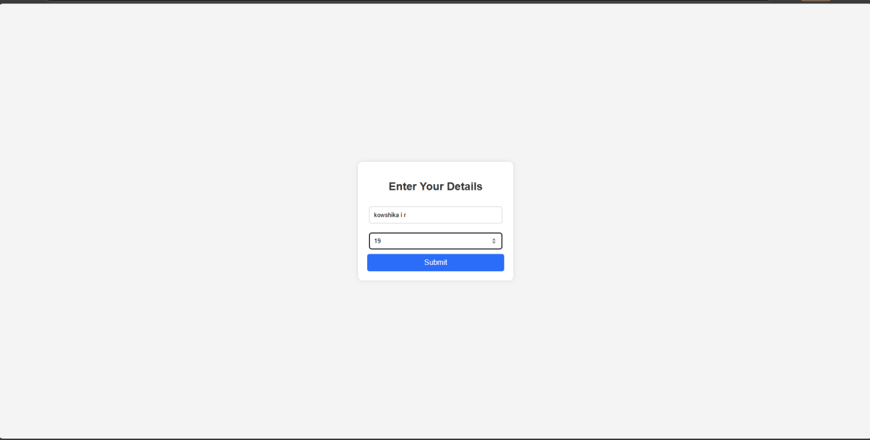

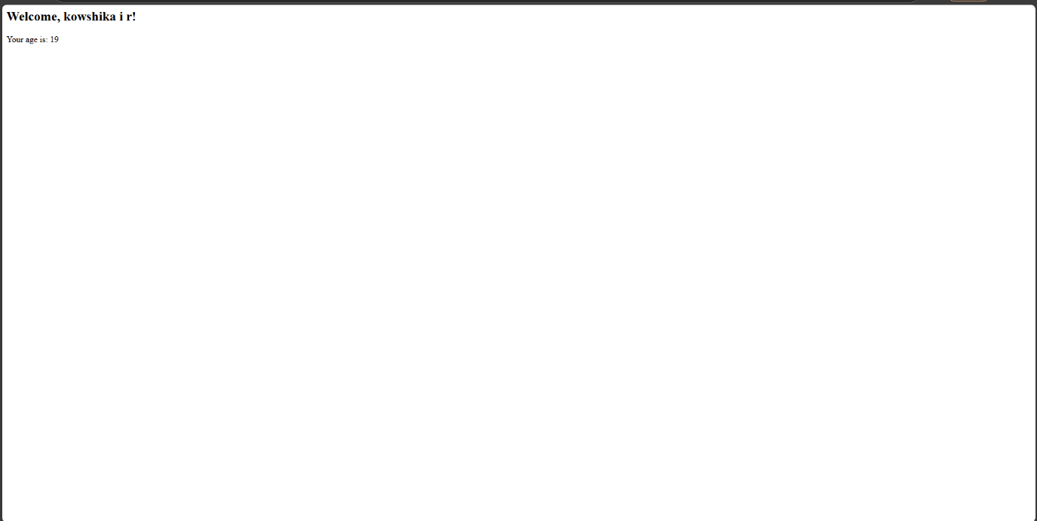

RESULT :
Thus the give program is executed successfully.

